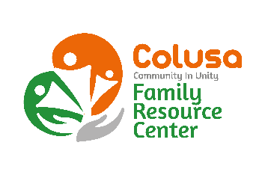
Ticket #

Colusa County Toys for Kids Program
131 5th Street
Colusa, CA 95932

Colusa CAPC and Family Resource Center in Colusa County is coordinating the CHP Toys for Kids Program. It may not be possible to provide toys for all families. However, if you would like to be considered for a toy, please fill out form completely including the Sponsor Information. The last day to turn in the form is Friday, December 9th, 2022. Please bring the form to us as quickly as possible to allow time for the group to plan. WE WILL NOT TAKE LATE APPLICATIONS! Application must be returned WITH BIRTH CERTIFICATE or SHOT RECORD ONLY for children 11 years and younger to be considered.
PLEASE MAIL, DROP OFF IN PERSON, or email them to mcotter@colusacapc.net NO LATER THAN DECEMBER 9th, 2022 by 4:30p.m **No longer accepting faxed applications **
I authorize the release of my name and address for Toys for Kids.
Name: ____________________________________ Spouse: ____________________________________

Telephone: ________________________________ Message phone: _____________________________
Street Address: ___________________________ City: _______________________ Zip: _________
Mailing address: ___________________________ City_______________________ Zip: _________
Number of persons in household: _________
Names and ages of children: Verified by: Birth Certificate Shot Record Initials: _____
M F___________________________ ______ M F__________________________ ______
M F___________________________ ______ M F__________________________ ______
M F___________________________ ______ M F__________________________ ______
Expected income in December of 2022: $__________ Source of income: _______________
________________________________________ _____________________________
Your Signature Date

Sponsor Information:
Must be filled out by the sponsor. YOU MUST HAVE A SPONSER!!
A sponsor is someone who knows you and can help us verify your assistance needs. They cannot be related to you. They can be clergy, schoolteacher, police or fireman, doctor, WIC, city or a county worker.
Note to sponsor: Please call if you have questions regarding this application 458-7678.

Sponsor’s name:____________________________ Occupation:_________________________

Telephone #1: ______________________________ Telephone #2: ______________________
________________________________________ _____________________________
Sponsor’s Signature Date

